

Exploring Death and Loss of Our Loved Ones
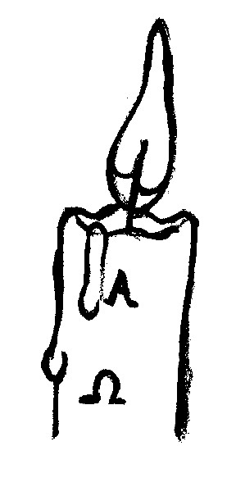
Residential Weekend led by

Fr. Myles O'Reilly S.J. and the Bethany Bereavement Support Group

This weekend explores the loss of our loved ones and the meaning of death from a Christian perspective through prayer, meditation, discussion, videos and sharing.

WHERE: Orlagh Retreat Centre, Old Court Rd., Dublin 16.
WHEN: Friday 20th November 2015 at 7.30p.m. to Sunday 22nd November 2015 at 4.30p.m.
COST: €180.00 per person (Deposit €50.00) All Meals included.
Apply to: Anne @ 087 2050514 or email: bethanysupport@eircom.net
BOOKING FORM
NAME:…………………………………………………………………………..................................................
ADDRESS:………………………………………………………………………………………………………
TEL:……………………FAX:…………………..MOBILE:…………..……………………………………...
I wish to book ___ place(s) on this workshop and enclose € _____Deposit/Full Payment.
Cheques to be made payable to: BETHANY BEREAVEMENT SUPPORT GROUP and forwarded to: Bethany Bereavement Support Group, c/o Rathfarnham Parish Centre, Willbrook Road, Rathfarnham, Dublin 14.

