

Exploring Death and Loss of Our Loved Ones
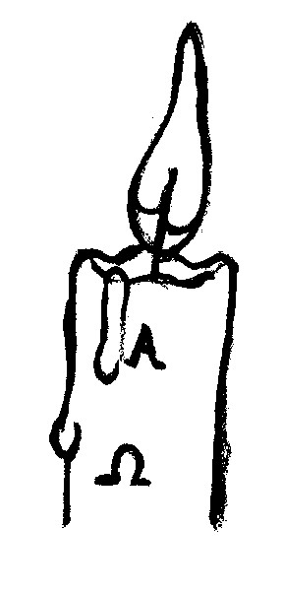

Residential Weekend led by

Fr. Myles O'Reilly S.J. and the Bethany Bereavement Support Group

This weekend explores the loss of our loved ones and the meaning of death from a Christian perspective through prayer, meditation, discussion, videos and sharing.
WHERE: Dominican Priory Centre, Tallaght Village, Dublin 24.
WHEN: Friday 25th November 2016 at 7.30p.m. to Sunday 27th November 2016 at 4.30p.m.
COST: €190.00 per person (Deposit €50.00 Non Refundable) All Meals included.
Apply to: Anne @ 087 2050514 or email: bethanysupport@eircom.net

BOOKING FORM
NAME:…………………………………………………………………………..................................................
ADDRESS:………………………………………………………………………………………………………
TEL:……………………FAX:…………………..MOBILE:…………..……………………………………...
I wish to book ___ place(s) on this workshop and enclose € _____Deposit/Full Payment.
Cheques to be made payable to: BETHANY BEREAVEMENT SUPPORT GROUP and forwarded to: Bethany Bereavement Support Group, c/o Rathfarnham Parish Centre, Willbrook Road, Rathfarnham, Dublin 14.

